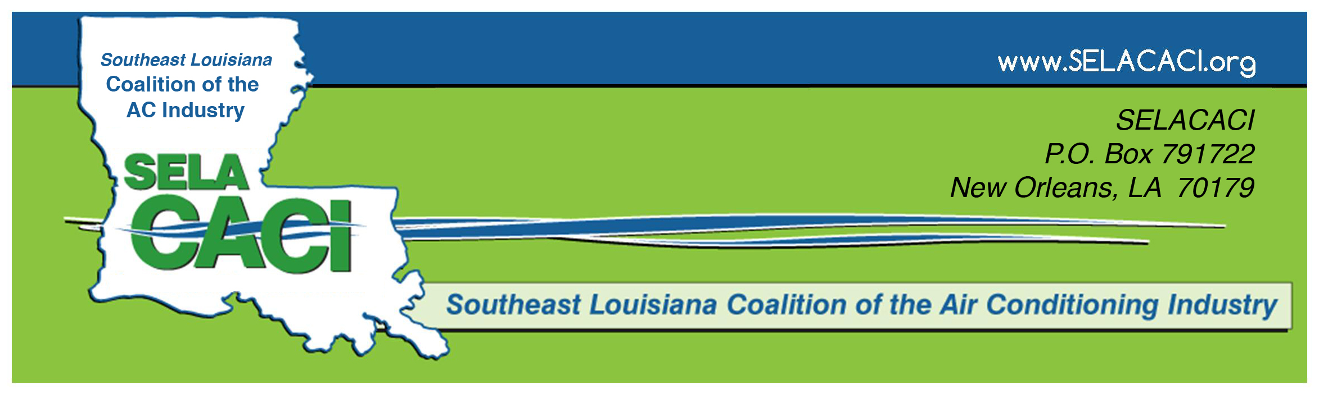
MEMBERSHIP SURVEY – “What You Don’t Know About Manual J” Program – 10/11/16

Did this program meet your expectations?
Any suggestions to improve future programs?

(Check one box for each line indicating your program picks…) |  | Not interested |  | Low priority |  | Medium priority | High priority
Ventilation Issues – How to Address Makeup Air for Kitchen Hoods & Tight Houses
Monthly Heatload Workshops – Problem-Solving & Skill Sessions – First Tuesdays, 5-7 p.m., Rosa Keller Library (Broad & Napoleon), New Orleans
Geothermal Heat Pumps – Raul Mena, Mena Air (&/or other)
Tips for Doing Load Calcs (all-day session: Manual J, D, & S)
Residential Code class – based on the code book, including a code book to take home (1-2 day class) – Spring 2017?
Solar Power & HVAC – Perceptions & Misperceptions
“How to Pass a Duct Test When You Otherwise Wouldn’t”
Natural Gas & Combustion Safety Testing & Issues
How to Address Sweating Ducts
“How A/C Contractors Can Work Better with Architects & Designers”
(Ed Cazayoux, AIA) “Energy Star by Design”
“Air Barriers & Insulation” -- Understanding the Significance of the New Construction Inspections (technically allowed in lieu of Blower Door Tests) by the 2009 Energy Code in Louisiana

Other Speakers/Topics / Suggestions: __________________________________________________________
Name/Company (optional)____________________________________________________________________
Name / Company___________________________________________________________________________

